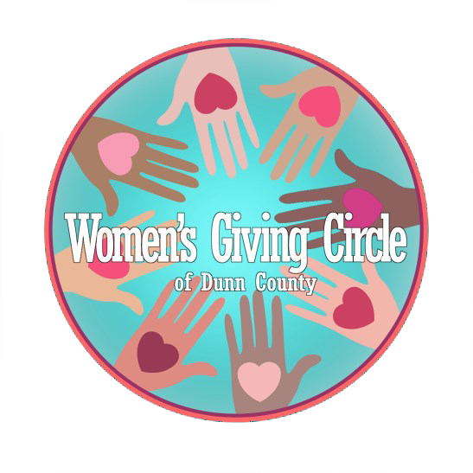
GRANTMAKING Committee Report

Amount of Dollars to Spend: $19,747
Agency Proposals Submitted: 23
Proposals Considered:14
Recommended Agency’s to Fund = 6
PROPOSALS FUNDED
- Girls on the Run: provide an 8-week spring program for girls grades 5-8 in Dunn County. $2247
- Menomonie School District: Purchase Feminine hygiene supplies for students in HS and Middle School. $1500
- Mission Restoring Hope Incorporated: Purchase 220 pairs of snow pants for low-income community children in Dunn County. All ages and all sizes. $4000
- Menomonie School District: Funds will be used to eliminate student lunch debt for low to moderate-income students so that all children can eat and zero barriers exist. $4000
- Salvation Army of Dunn County: Funds will be used to assist women, and women with children, with rent assistance, utility support, emergency housing, and transportation. Would assist anywhere from 8-15 women. $4000
- United Way St. Croix and Red Cedar Valleys, Inc.: These funds would provide diapers for the diaper bank. $4000
PROPOSALS NOT FUNDED
- ADRC of Dunn County: Provide Personal Emergency Response Systems to low -income Dunn County residents – for seniors only.
- Big Brother Big Sisters of Northwestern WI: To fund Big Little Events (food and activities)
- Chippewa Valley Council, Scouting America: Support Girls in the National Youth Leadership Training.
- Colfax, WI Splash Pad and Playground: Not a non-profit and asking for funds to build a new playground with a splash pad.
- Dunn County Historical Society: Fund a “Music Garden” outdoor play space.
- House Calls of Menomonie, Inc.: Would fill a milage gap for individuals who make house calls to the elderly in their homes.
- Menomonie Theater Guild: Funds for Scholarships to theater camps and offset cost of Shakespeare in the park.
- Wisconsin Milkweek Alliance, Inc.: Increase access to peer support for women and help to navigate community resources.
PROGRAMS NOT CONSIDERED
- Arbor Place, Inc – Funded last year.
- Glenwood City Public Library – Not in Dunn County.
- Hoof Beat Therapeutic Healing Center – Funded last year.
- Junior Achievement of WI, Northwest Area – Funded last year.
- Mabel Tainter Theater – Funded last year.
- Positive Alternatives, Inc. – asked for operational costs.
- Sleep in Heavenly Peace, Inc. – Funded last year.
- Stepping Stones of Dunn County – Funded last year.
- Bridge to Hope – Funded last year.
OTHER DECISIONS
- Will continue with the 7th Grade Philanthropy program: $1,000
- Will not establish an emergency funding opportunity.
- Will not establish a theme-based guideline for next years grant proposals.

