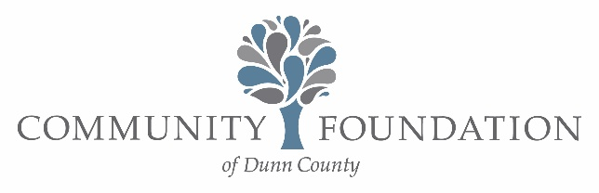

Lucy and Michael Nicolai Charitable Fund
NON-ENDOWED DESIGNATED FUND AGREEMENT AMENDMENT

MAY 2026

The Board of Directors resolves to amend the Lucy and Michael Nicolai Charitable Fund created for public, educational and charitable purposes for the benefit of specific organizations by adding the following organization…

UW-River Falls Foundation, 410 S. 3rd St., River Falls, WI 54022

Adopted by the Board of Directors: ___________________.

_______________________________________ _______________________

Georgina Tegart, Executive Director Date

_______________________________________ _______________________

Bradley Waznik, Chair Date

