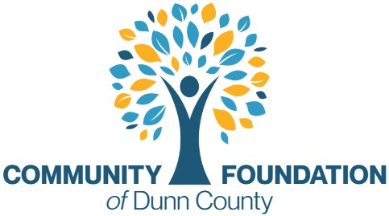

Vote Required - Acceptance of the 2026 Mondovi High School Scholarship nominees.

Submitted by the Scholarship Advisory Committee in compliance with CFDC's nondiscriminatory scholarship criteria. Georgina Tegart, Executive Director, affirms that scholarship selection meets all applicable state and federal laws and internal CFDC policies & procedures. Georgina Tegart, Executive Director, affirms that the following graduating seniors meet all the criteria to receive this scholarship:

First Name | Last Name | SCHOLARSHIP TITLE | High School | AMOUNT
No Applicants |  | 2026 Annabel Bauer BSN Nursing Scholarship | Mondovi | $2,000
Hunter | Wik | 2026 Dr. Darrell Sharp Memorial Scholarship | Mondovi | $250

