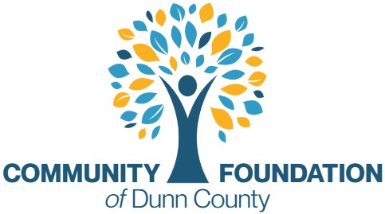

AHEC Community Health Internship Program
(https://www.nwwisconsinahec.org/programs)
Overview
Community indicators are data-driven metrics used by community foundations to measure local well-being and track social, economic, and environmental changes. Foundations use these baselines to guide grantmaking, align donor strategies, and tackle root causes of systemic issues.

2026 Intern Team
- 2 Master of Public Health students
  - Funded through the North Central Wisconsin AHEC CHIP Program
  - 40 hours during the summer internship period
- 1 additional community indicators intern
  - Supported directly by CFDC
  - 40 hours for 3 months during the summer internship period
  - Summer stipend: $2,400, credit and possible additional stipend form Mayo.
Project Focus: Dunn County Vital Signs / Community Indicators Initiative
The internship team will work with the Community Foundation of Dunn County to expand and strengthen local community data resources that help identify needs, trends, and opportunities across Dunn County.
The project is designed to support:
- Community health and wellbeing research
- Nonprofit and grantmaking strategy
- Public access to local data
- Long-term community planning
- Cross-sector collaboration
Areas of Research May Include
- Housing
- Mental health
- Substance abuse
- Food insecurity
- Childcare access
- Economic mobility
- Education outcomes
- Rural health access
- Population and demographic trends
Intern Responsibilities
- Collect and analyze local data
- Research state and national benchmark comparisons
- Develop community indicator dashboards and summaries
- Meet with nonprofit, government, education, and healthcare partners
- Assist with public-facing reports and presentations
- Participate in AHEC weekly seminars and professional development programming
Project Goal
To create a stronger, data-informed understanding of community conditions in Dunn County that can help guide philanthropy, nonprofit strategy, grantmaking, and future community investments.
Sample Indicators/ More Reading
https://ircommunityfoundation.org/resources/indicators/
https://arrasfoundation.org/wp-content/uploads/2020/05/COMMUNITY-INDICATORS-TOOLKIT-_-EXECUTIVE-SUMMARY.pdf
https://dashboards.mysidewalk.com/cfsc-indicators
https://colliercf.org/what-we-do/community-indicators/
https://cfleads.org/going-all-in/influencing-policy-and-systems/

